**Lab 2**

**21k-3881**

**Task 01**

import java.util.*;  
public class t1 {  
 public static void main(String[] args) {  
 rectangle rec=new rectangle();  
 rec.getArea();  
 circle cir=new circle();  
 cir.getArea();  
 triangle tri=new triangle();  
 tri.getArea();  
 } }  
interface shape{  
 void getArea(); }  
class rectangle implements shape{  
 @Override  
 public void getArea(){  
 Scanner x=new Scanner(System.*in*);  
 System.*out*.println("For rectangle :");  
 System.*out*.print("input length = ");  
 float l=x.nextFloat();  
 System.*out*.print("input width = ");  
 float w=x.nextFloat();  
 float out=l*w;  
 System.*out*.println("rectangle area = "+out); }  
}  
class circle implements shape{  
 @Override  
 public void getArea() {  
 Scanner x=new Scanner(System.*in*);  
 System.*out*.println("\nFor circle :");  
 float p=(float) 3.14;  
 System.*out*.println("pi value = "+p);  
 System.*out*.print("input radius value = ");  
 float rad=x.nextFloat();  
 float out=p*(rad*rad);  
 System.*out*.println("circle area = "+out);}  
}  
class triangle implements shape{  
 @Override  
 public void getArea() {  
 Scanner x=new Scanner(System.*in*);  
 System.*out*.println("\nFor triangle :");  
 System.*out*.print("input base value = ");  
 float b=x.nextFloat();  
 System.*out*.print("input height = ");  
 float h=x.nextFloat();  
 float out=(h*b)/2;  
 System.*out*.println("triangle area = "+out);  
 }  
}

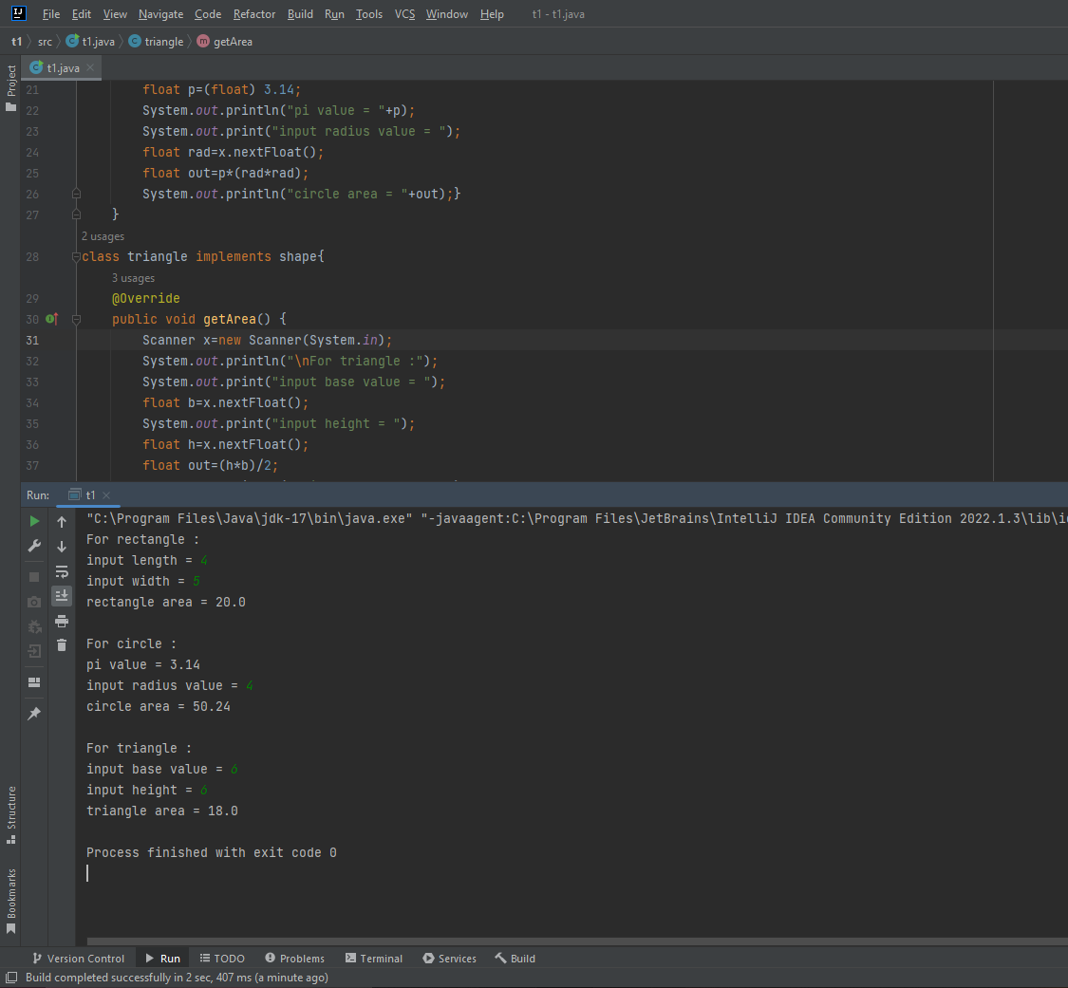

**Task 02**

import java.util.*;  
interface animal{  
 public void barking(); }  
class dog implements animal{  
 @Override  
 public void barking() {  
 System.*out*.println("dog is Barking!!!"); }  
}  
public class t2{  
 public static void main(String[] args) {  
 dog b=new dog();  
 b.barking(); } }

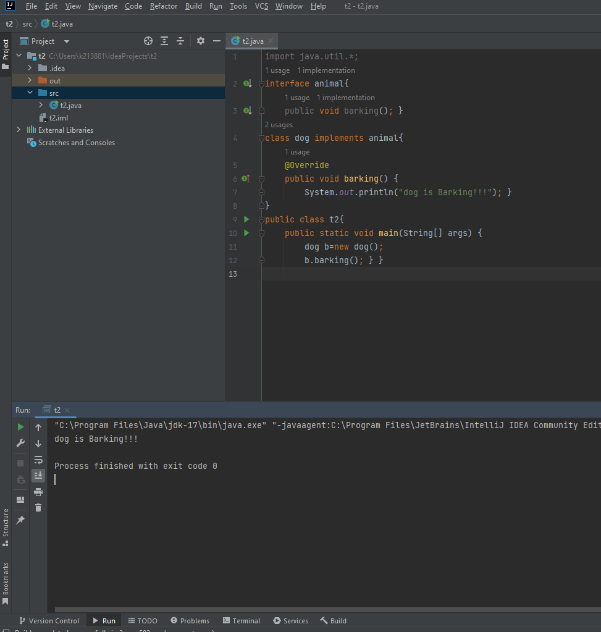

**Task 03**

import java.util.*;  
interface account{  
 void with();  
 void dep();  
 void interest();  
 float *bal*=1500;}  
class cur_Acc implements account{  
 float b=*bal*,in;  
 String acc_no;  
 cur_Acc(String acc_no){  
 this.acc_no=acc_no; }  
 void with(){  
 Scanner x=new Scanner(System.*in*);  
 System.*out*.print("input widthdraw amount = ");  
 float w=x.nextFloat();  
 b=b-w;  
 System.*out*.println("Account balance = "+b); }  
 void dep(){  
 Scanner x=new Scanner(System.*in*);  
 System.*out*.print("input deposite amount = ");  
 float d=x.nextFloat();  
 b=b+d;  
 System.*out*.println("Account balance = "+b); }  
 void interest(){  
 System.*out*.println("Interest... ");  
 Scanner x=new Scanner(System.*in*);  
 System.*out*.print("Rate = ");  
 float r=x.nextFloat();  
 float t=12;  
 in=t*r*b; }  
 void print(){  
 System.*out*.println("Your account number is = "+acc_no);  
 System.*out*.println("Balance = "+b);  
 System.*out*.println("Interest = "+in); }  
}  
class sav_Acc implements account{  
 String acc_no;  
 float b=*bal*,in,bon;  
 sav_Acc(String acc_no){  
 this.acc_no=acc_no; }  
 void with(){  
 Scanner x=new Scanner(System.*in*);  
 System.*out*.print("Widthdraw amount = ");  
 float w=x.nextFloat();  
 b=b-w;  
 System.*out*.println("Account balance = "+b); }  
 void dep(){  
 Scanner x=new Scanner(System.*in*);  
 System.*out*.print("input deposite amount = ");  
 float d=x.nextFloat();  
 b=b+d;  
 System.*out*.print("Account balance = "+b); }  
 void bonus(){  
 bon=0.05f*b; }  
 void interest(){  
 System.*out*.println("Interest...");  
 Scanner x=new Scanner(System.*in*);  
 System.*out*.print("Rate = ");  
 float r=x.nextFloat();  
 float t=12;  
 in=b*r*t; }  
 void print(){  
 System.*out*.println("Your account number is = "+acc_no);  
 System.*out*.println("Balance: "+b);  
 System.*out*.println("Interest: "+in);  
 System.*out*.println("Bonus: "+bon); }  
}  
public class t3{  
 public static void main(String[] args) {  
 Scanner x = new Scanner(System.*in*);  
 for (int i = 0; i < 2; i++) {  
 System.*out*.println("Account Type from the following");  
 System.*out*.println("1)Current Account 2) Saving Account");  
 int sel = x.nextInt();  
 if (sel == 1) {  
 System.*out*.println("Current Account...");  
 cur_Acc a = new cur_Acc("001122");  
 System.*out*.println("1) Withdraw 2) Deposite");  
 int ch = x.nextInt();  
 if (ch == 1) {  
 a.with();  
 }

else if (ch == 2) {  
 a.dep();  
 }  
 a.interest();  
 a.print();  
 }

else if (sel == 2) {  
 System.*out*.println("Saving account...");  
 sav_Acc p = new sav_Acc("001122");  
 System.*out*.println("1) Withdraw 2)Deposite");  
 int ch = x.nextInt();  
 if (ch == 1) {  
 p.with();  
 }

else if (ch == 2) {  
 p.dep();  
 }  
 p.bonus();  
 p.interest();  
 p.print();  
 } }  
 } }

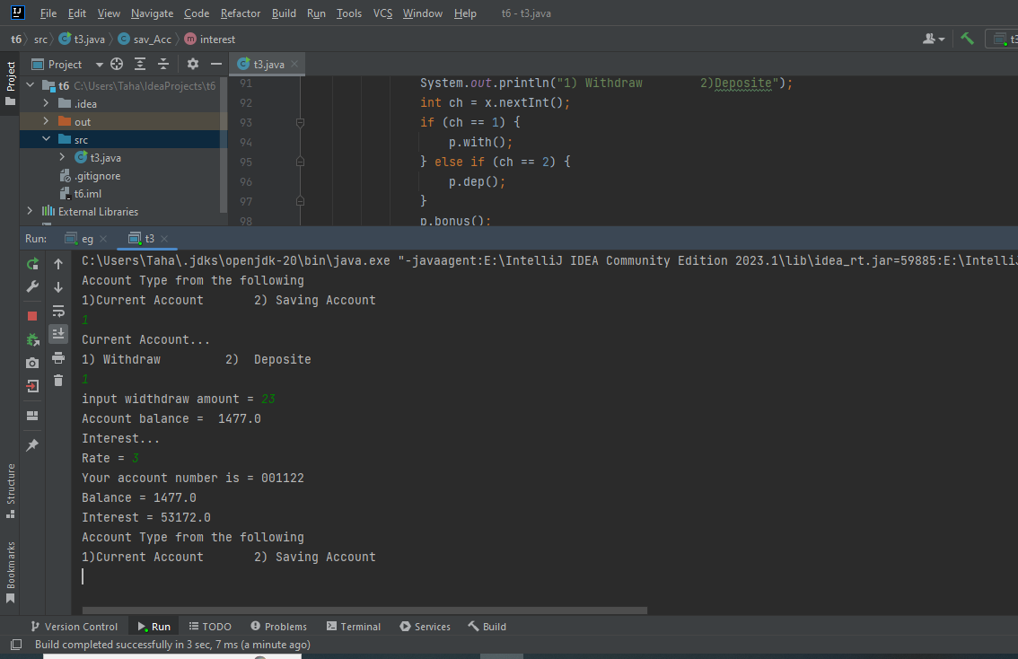

**Task 04**

public class t4{  
 public static void main(String[] args) {  
 circle c=new circle();  
 c.draw();  
 System.*out*.println("");  
 rectangle r=new rectangle();  
 r.draw();  
 System.*out*.println("");  
 triangle t=new triangle();  
 t.draw();  
 System.*out*.println("");  
 }  
}  
interface shape{  
 void draw(); }  
class circle implements shape{  
 @Override  
 public void draw(){  
 System.*out*.println("Circle...");  
 int a=2,p,q;  
 int n=2*a+1;  
 for (int x=0;x<n;x++){  
 for (int y=0;y<n;y++){  
 p=x-a;  
 q=y-a;  
 if(p*p+q*q<=a*a+1)  
 System.*out*.print("+");  
 else  
 System.*out*.print(" ");  
 System.*out*.print(" "); }  
 System.*out*.print("\n"); }  
 }  
}  
class rectangle implements shape{  
 @Override  
 public void draw() {  
 System.*out*.println("Rectangle...");  
 System.*out*.print(" ");  
 for(int x=0;x<=5;x++)  
 System.*out*.print("+");  
 System.*out*.println();  
 for(int y=0;y<5;y++)  
 System.*out*.println("+ +");  
 System.*out*.print(" ");  
 for(int z=0;z<=5;z++)  
 System.*out*.print("+");  
 }  
}  
class triangle implements shape{  
 @Override  
 public void draw(){  
 System.*out*.println("Triangle...");  
 for(int i=1;i<=4;i++){  
 for(int j=1;j<=(4-i);j++){  
 System.*out*.print(" "); }  
 for(int k=0;k<(i+(i-1));k++){  
 System.*out*.print("+"); }  
 for(int w=1;w<=(4-i);w++){  
 System.*out*.print(" "); }  
 System.*out*.println(); }  
 } }

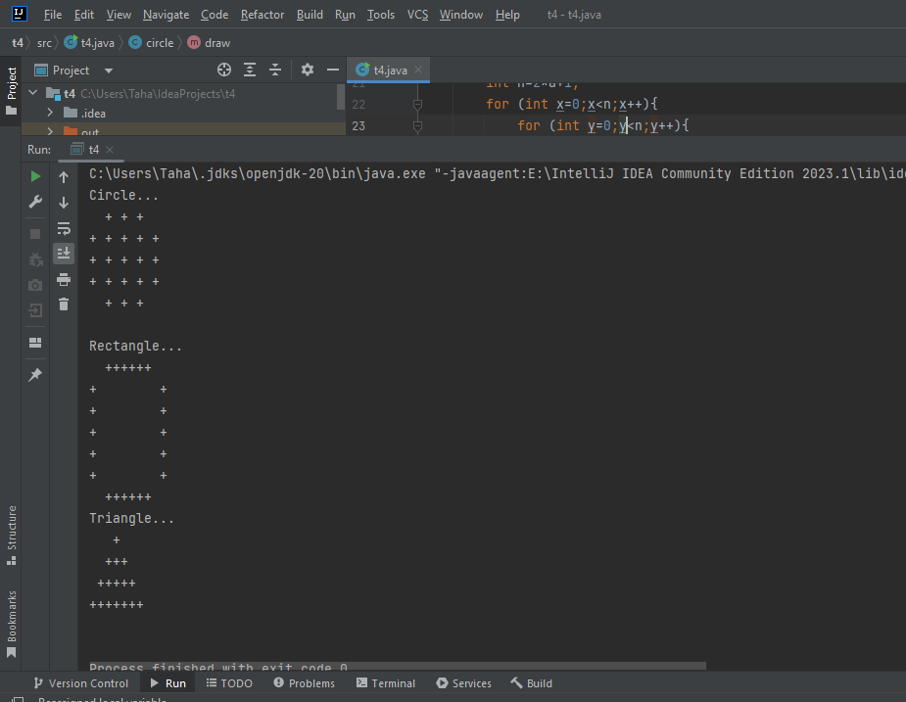

**Task 05**

class Animal{  
 void make_Sound() {}  
 void move() {}  
}  
  
class Panthera extends Animal{  
 @Override  
 void make_Sound() {  
 System.*out*.println("Panthera loudly Roars"); }  
 void move(){  
 System.*out*.println("Panthera walks through their legs"); }  
}  
class Bird extends Animal{  
 @Override  
 void make_Sound() {  
 System.*out*.println("Birds loudly Whistle"); }  
 void move(){  
 System.*out*.println("Birds fly through their wings "); }  
 }  
public class t5 {  
 public static void main(String[] args) {  
 Panthera pan=new Panthera();  
 System.*out*.println("Panthera :");  
 pan.make_Sound();  
 pan.move();  
 Bird bir=new Bird();  
 System.*out*.println("Birds :");  
 bir.make_Sound();  
 bir.move();  
 }  
  
}

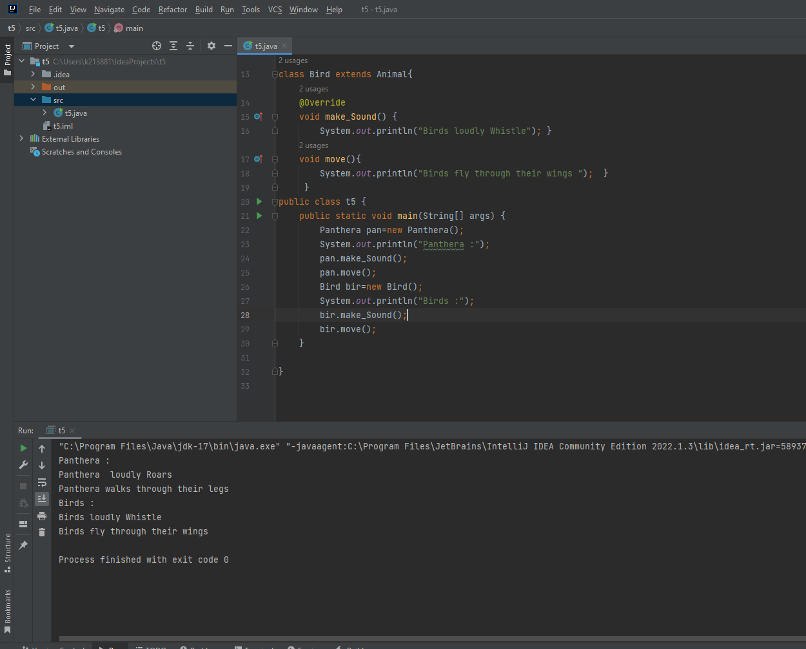

**Task 06**

public class t6{  
 public static void main(String[] args) {  
 Tiger tig=new Tiger();  
 System.*out*.println("Tiger :");  
 tig.Sound();  
 tig.Eat();  
 System.*out*.println(" ");  
 Panther pan=new Panther();  
 System.*out*.println("Panther :");  
 pan.Sound();  
 pan.Eat();  
 Lion li=new Lion ();  
 System.*out*.println(" ");  
 System.*out*.println("Lion :");  
 li.Sound();  
 li.Eat();  
 } }  
class Animal{  
 void Sound() {}  
 void Eat() {}  
}  
class Tiger extends Animal{  
 @Override  
 void Sound(){  
 System.*out*.println("Tiger loudly growl,roar "); }  
 void Eat(){  
 System.*out*.println("Tiger likes eating arge prey!!!"); }  
}  
class Panther extends Animal{  
 @Override  
 void Sound(){  
 System.*out*.println("Panther loudly growls"); }  
 void Eat(){  
 System.*out*.println("Panther likes eating deer, wild hogs!!!"); }  
}  
class Lion extends Animal{  
 @Override  
 void Sound(){  
 System.*out*.println("Lion loudly Roars"); }  
 void Eat(){  
 System.*out*.println("Lion likes eating d/f animals meat!!!"); }  
}

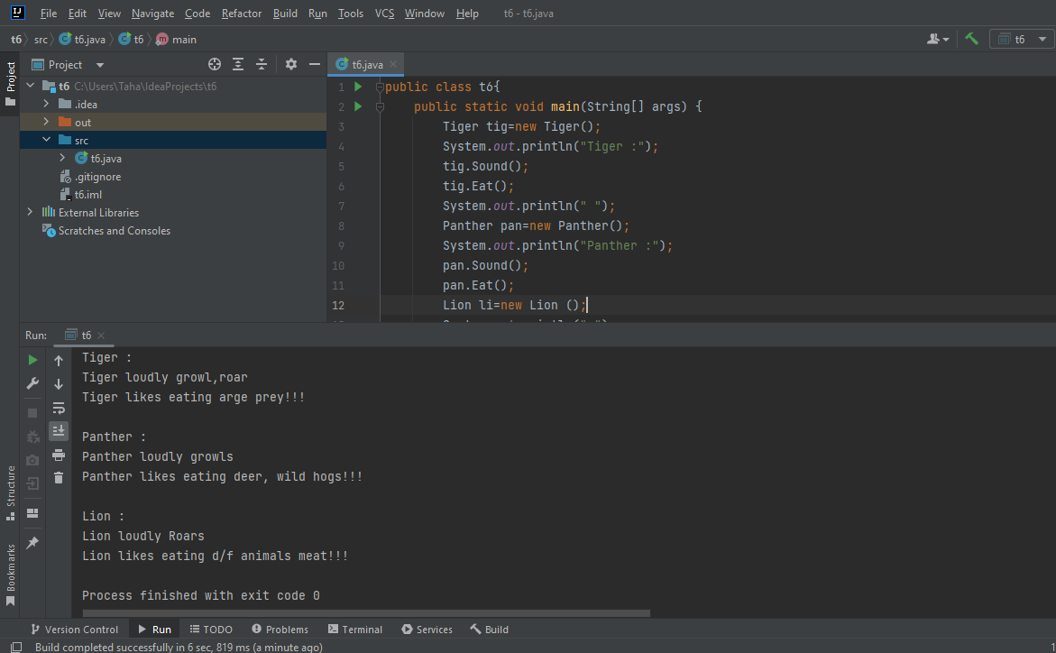

**Task 07**

import java.util.*;  
abstract class employee{  
 abstract void cal_Salary();  
 abstract void display(); }  
class programmer extends employee{  
 int m_sa,an_sa;  
 String ID,d;  
 public void cal_Salary(){  
 Scanner x=new Scanner(System.*in*);  
 System.*out*.print("Department = ");  
 d=x.next();  
 System.*out*.print("ID = ");  
 ID=x.next();  
 System.*out*.print("input your monthly salary = ");  
 m_sa=x.nextInt();  
 an_sa=m_sa*12; }  
 public void display(){  
 Scanner x=new Scanner(System.*in*);  
 System.*out*.print("Department = "+d+" ; ");  
 System.*out*.print("ID: "+ID+" ; ");  
 System.*out*.print("Your monthly salary = "+m_sa+" ; ");  
 System.*out*.print("Your annual salary = "+an_sa); }  
}  
class manager extends employee{  
 int m_sa,an_sa;  
 String d,ID;  
 public void cal_Salary() {  
 Scanner x=new Scanner(System.*in*);  
 System.*out*.print("Department = ");  
 d=x.next();  
 System.*out*.print("ID = ");  
 ID=x.next();  
 System.*out*.print("input your monthly salary = ");  
 m_sa=x.nextInt();  
 an_sa=m_sa*12; }  
 public void display(){  
 Scanner x=new Scanner(System.*in*);  
 System.*out*.print("ID = "+ID+" ; ");  
 System.*out*.print("Department = "+d+" ; ");  
 System.*out*.print("Your monthly salary = "+m_sa+" ; ");  
 System.*out*.print("Your annual salary = "+an_sa); }  
}  
public class t7 {  
 public static void main(String[] args) {  
 Scanner x = new Scanner(System.*in*);  
 System.*out*.println("1)Programmer\n2)Manager");  
 for (int i = 0; i < 2; i++) {  
 System.*out*.print("input your choice :");  
 int choice = x.nextInt();  
 if (choice == 1) {  
 System.*out*.println("Programmer!!!");  
 programmer pro = new programmer();  
 pro.cal_Salary();  
 pro.display();  
 System.*out*.println();  
 }  
 else if (choice == 2) {  
 System.*out*.println("Manager");  
 manager man = new manager();  
 man.cal_Salary();  
 man.display();  
 } }  
 } }

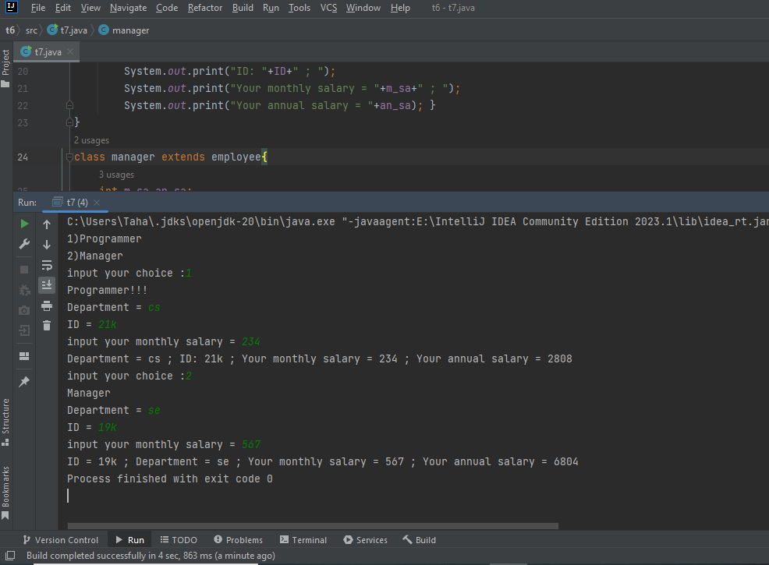

**Task 08**

import java.util.*;  
public class t8{  
 public static void main(String[] args) {  
 System.*out*.println("For Triangle... ");  
 Geometric_Shape tri=new Triangle();  
 System.*out*.println("Perimeter of triangle : ");  
 tri.Perimeter();  
 System.*out*.println();  
 System.*out*.println("Area of triangle = ");  
 tri.Area();  
 Geometric_Shape sq=new Square();  
 System.*out*.println();  
 System.*out*.println("For Square... ");  
 System.*out*.println("Area of square : ");  
 sq.Area();  
 System.*out*.println(" ");  
 System.*out*.println("Perimeter of square : ");  
 sq.Perimeter();  
 } }  
abstract class Geometric_Shape {  
 void Perimeter() {}  
  
 void Area() {}  
}  
class Triangle extends Geometric_Shape{  
 Scanner x=new Scanner(System.*in*);  
 public void Perimeter(){  
 System.*out*.print("input base = ");  
 int b=x.nextInt();  
 System.*out*.print("input side 1 = ");  
 int s1=x.nextInt();  
 System.*out*.print("input side 2 = ");  
 int s2=x.nextInt();  
 int p=b*s1*s2;  
 System.*out*.print("Perimeter = "+p); }  
 public void Area(){  
 System.*out*.print("input height = ");  
 int h=x.nextInt();  
 System.*out*.print("input base = ");  
 int b=x.nextInt();  
 int ar=(h*b)/2;  
 System.*out*.print("Area = "+ar); }  
}  
class Square extends Geometric_Shape{  
 Scanner x=new Scanner(System.*in*);  
 public void Perimeter(){  
 System.*out*.print("input side = ");  
 int side=x.nextInt();  
 int p=4*side;  
 System.*out*.print("Perimeter = "+p); }  
 public void Area(){  
 System.*out*.print("input side = ");  
 int side=x.nextInt();  
 int ar=side*side;  
 System.*out*.print("Area = "+ar); }  
}

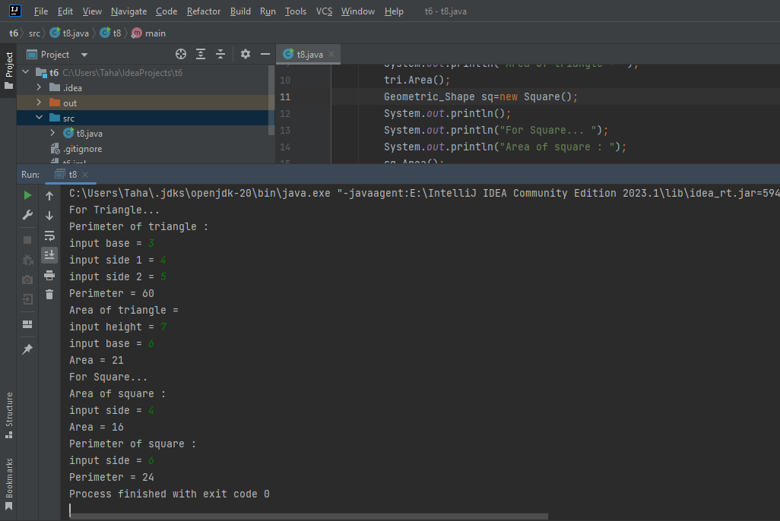

**Task 09**

import java.util.*;  
abstract class bird{  
 abstract void make_Sound();  
 abstract void fly(); }  
class hawk extends bird{  
 public void fly(){  
 System.*out*.println("Hawk flie through wings!!!"); }  
 public void make_Sound(){  
 System.*out*.println("Hawk loudly hoarse!!!"); }  
}  
class eagle extends bird{  
 public void make_Sound(){  
 System.*out*.println("Eagle whistle!!!"); }  
 public void fly(){  
 System.*out*.println("Eagle flie wieh wings!!!"); }  
}  
public class t9{  
 public static void main(String[] args){  
 System.*out*.println("Hawk...");  
 hawk ha=new hawk();  
 ha.make_Sound();  
 ha.fly();  
 System.*out*.println("Eagle...");  
 eagle ea=new eagle();  
 ea.make_Sound();  
 ea.fly();  
 } }

